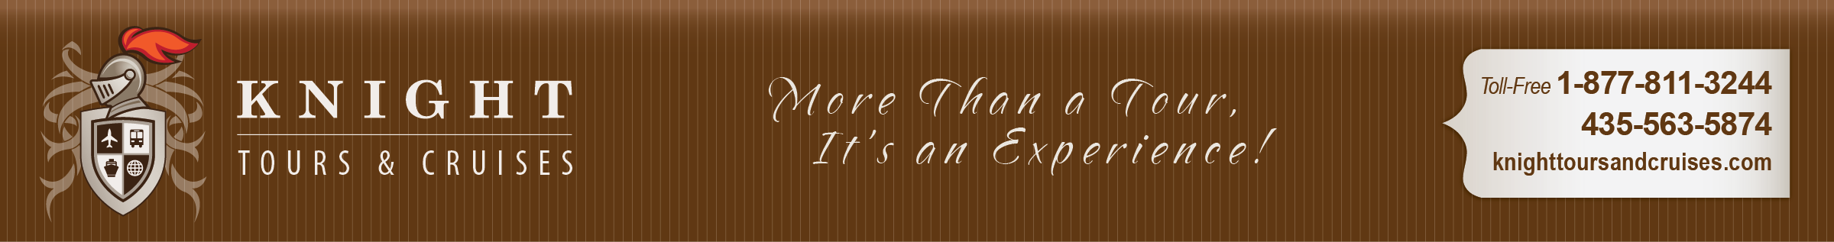
Seattle, Washington – The “Emerald City” is beautifully situated among rivers, lakes and a beautiful mountainous backdrop. We have packaged hotel accommodations for the night prior to sailing along with a Seattle sightseeing tour plus transfers to the ship. You’ll want to spend time in this energizing city.
Ketchikan, Alaska – Discover why Ketchikan is also known as the “Salmon Capital of the World.” The city is built on steep hillsides along the water and features a colorful and bustling port.
Cruising Tracy Arm Fjord – As you glide through this pristine fjord, you’ll first pass by a lush forest where a number of beautiful waterfalls cascade down, and then you’ll be treated to views of snowcapped mountains and blue-tinged glaciers more spectacular than you could ever imagine. Breathtaking Tracy Arm extends over 30 miles long, with nearly a quarter of its area covered in ice. In fact, it encompasses some of Alaska’s largest glaciers.
Juneau – Here in the Capital city you may wish to take a quick tram ride up Mt. Roberts for amazing views or visit monumental Mendenhall Glacier, the largest glacier accessible by road.
Skagway – Experience yesteryear along Skagway’s charming boardwalk lined with buildings that replicate the Gold Rush days. Perhaps you’ll want to join an optional excursion onboard the White Pass Railway for a tour that combines history and beauty into the Yukon Territory.
Victoria, British Columbia, Canada –
This sophisticated seaside city is the sunniest spot in Canada. Here you may wish to take a stroll through the spectacular 35-acre Butchart Gardens or visit the Empress Hotel. You’ll love this port which is filled with old-world charm.

Alaska Cruise
Sailing onboard the beautiful Emerald Princess August 25 – September 2, 2018
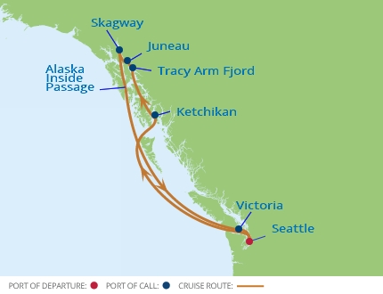

Alaska is waiting for you!
From the crackle of a towering glacier calving,
to a spouting whale and Gold Rush-era towns
like Skagway and Ketchikan, you can
experience the best of Alaska on your thrilling
Inside-Passage Cruise with Princess Cruises.

Rates beginning at $1699.00 which includes airfare from Salt Lake City.
Also included: one night hotel accommodations in Seattle, a Seattle sightseeing tour, and transfers to and from the ship.

Schedule: |  | ARRIVAL | DEPARTURE
Sat Aug 25 | Fly to Seattle, tour Seattle and hotel accommodations |  | 4:00 PM
Sun Aug 26 | Board the ship
Mon Aug 27 | Cruise inside passage | 7:00 AM | 4:00 PM
Tue Aug 28 | Ketchikan, Alaska | 6:00 AM | 10:00 AM
Wed Aug 29 | Tracy Arm Fjord Region | 1:30 PM | 10:00 PM
Wed Aug 29 | Juneau, Alaska | 7:00 AM | 6:00 PM
Thurs Aug 30 | Skagway, Alaska | 6:30 PM | 10:30 PM
Fri Aug 31  Sat Sept 1 | At Sea  Victoria, British Columbia
Sun Sept 2 | Fly home from Seattle | 5:30 PM | 11:59 PM
Fri Sep 1 | Disem  bark ship and fly home | disembark

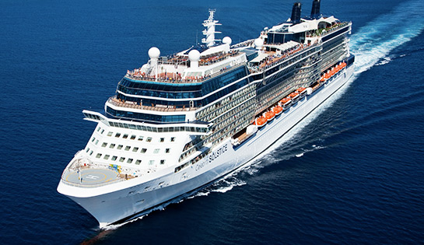

Inside Cabin $1639.00
(no window or porthole)

Ocean View Stateroom $1989.00
(full view) (very limited availability for ocean view staterooms)

Balcony Stateroom $2339.00
(private balcony)

Mini Suite (with private balcony) $2589.00

All rates are per person and based upon double occupancy. Government fees and taxes are an additional $278.51 per person. Please call for triple/quad or single occupancy rates. Fuel surcharge could be added should oil prices increase dramatically.
Airfare from other cities can be arranged. Please contact Knight Tours & Cruises for assistance if needed.

Place your reservations by Nov. 16 for FREE features and reduced deposit of $100.00.

 

Airfare from Salt Lake City is included in the above mentioned rates as well as hotel, transfers and a Seattle tour.

For these special group rates you must make your reservation with Knight Tours & Cruises. Space is on a first come – first served basis. The cabins with the best location are the first to sell out.

A valid passport is required for this cruise.

Registration Information: Please fill out the enclosed reservation form and return it as soon as possible (with the required deposit of $400.00 per person) to secure your space on this cruise. Reservations cannot be accepted without payment. Deposits may be made by credit card or check. If paying by check please make your checks payable to: KNIGHT TOURS & CRUISES, LLC. No credit cards will be accepted for the final payment.

Final payment is due on or before April 17, 2017. Please keep notify us of any address changes.
Cancellation Policy: For cancellations prior to January 15, 2018 will be refunded in full less a $20 administrative fee per person. Cancellations between January 16, 2018 and April 17, 2018 will result in loss of paid deposit. No refunds for cancellations after April 17, 2018 or for no shows. The purchase of optional travel insurance is strongly recommended. Some of the benefits of travel insurance include: Refund of money lost for trip cancellation caused by medical or family emergencies, medical expense benefits in case of injury or sickness while you travel, and more. Please inquire for more details and about affordable rates. Travel insurance may be purchased at an optional per person rate of $135 to $166 based upon cost of your cruise package.

Terms & Conditions: Knight Tours & Cruises, LLC (Agent) is acting as an agent for suppliers of air and ground transportation, hotel accommodations, meals, tours, cruises, etc. in selling travel-related services, or in accepting reservations or bookings for services that are not directly supplied by Agent. Agent attempts to represent only those suppliers of travel that have shown an acceptable level of stability, dependability and responsiveness to problems and complaints. As such, Agent shall not be liable for injury, damage, accident, loss, delay or irregularity which may be occasioned either by reasons of defect in any vehicle or mode of transportation, through the acts, defaults, financial difficulty or bankruptcy or omissions of the Supplier or person engaged in carrying out the arrangements of the trip or otherwise in connection therewith. Agent is not liable for delays and/or cancellations or services and resultant expenses or loss caused by acts of God, sickness, weather, strikes, war, quarantine, terrorism, social or labor unrest, labor laws, mechanical or construction difficulties, abnormal conditions or other situations, actions, omissions or conditions outside Agent’s control. Agent is not liable for loss of or damage to baggage or personal possessions. Agent reserves the right to alter or cancel the itinerary or substitute services as conditions require or for the safety of Passenger.
You must report any disability requiring special attention at the time the reservation is made. The purchase of this tour is the purchase of a complete package, therefore, no refunds will be made for individual components or activities not use or participated in.

_ _ _ _ _ _ _ _ _ _cut here _ _ _ _ _ _ _ _ _ _ _ _ _ _ _ _ _ _ _ _ _ _ _ cut here _ _ _ _ _ _ _ _ _ _ _

Reservation Form

Princess Cruise Lines  Alaska Inside Passage Cruise  August 25 – Sept. 2, 2018

Name:______________________________ Birth date:__________ Male/Female U.S. Citizen ___
(name must appear exactly as indicated on your passport)

Name:______________________________ Birth date:__________ Male/Female U.S. Citizen____
(name must appear exactly as indicated on your passport)
Alaska Inside Passage Cruise

Emerald Princess * August 25 – Sept. 2, 2018
Please mail your reservation form and $400.00 per person deposit to:

Knight Tours & Cruises
Attn: Barry
777 East 400 South
Smithfield, UT 84335
Toll-free 1-877-811-3244

Address:____________________________

City:_____________State:_____Zip:_____

Phone:_____________________________

Cell phone:____________________________________

Email address:_______________________

Special Requests:_____________________

Type of cabin: (circle one) Inside Cabin ~ Ocean View ~ Balcony Stateroom

Credit card #______________________________Expire ____/____ CVS Code _____
Signature____________________________________________ Date ______________

Do you want to purchase travel insurance? YES NO
By submitting this reservation form, I indicate that I am aware of the terms & conditions, cancellation penalties, and need of
a current passport for this cruise.

